**ARRAYS**

**LAB # 7**



**Spring 2019**

**CSE102L Computer Programming Lab**

Submitted by: **Shah Raza**

Registration No. : **18PWCSE1658**

Class Section: **B**

“On my honor, as student of University of Engineering and Technology, I have neither given nor received unauthorized assistance on this academic work.”

Student Signature: ______________

Submitted to:

**Engr. Madiha Sher**

March 8,2019

Department of Computer Systems Engineering

University of Engineering and Technology, Peshawar

**TASK #1:**

Write a program to input twelve numbers from user using array and display all values on console (3 values in a row) (use seperate loops for input and output operation).

**Code:**

#include <iostream>

using namespace std;

int main()

{

int A[12];

for(int i=0;i<12;i++) //Input Array

{

cout<<"Enter number "<<i+1<<": ";

cin>>A[i];

}

int counter=0;

for(int i=0;i<12;i++) //Display Array

{

cout<<"Value "<<i+1<<" = "<<A[i]<<"\t";

counter++;

if(counter==3)

{

cout<<endl;

counter=0;

}

}

return 0;

}

**Output (Compilation, Testing and Debugging):**

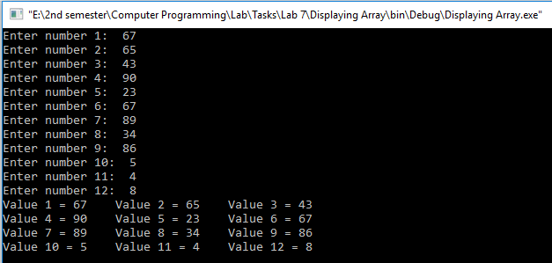

**TASK #2:**

Write a program to input ten numbers from user using array and find the average of numbers (use separate loops for input operation and calculation).

**Code:**

#include <iostream>

using namespace std;

int main()

{

const int SIZE=10;

int A[SIZE];

float sum=0.0;

for(int i=0;i<SIZE;i++) //Input Array

{

cout<<"Enter a number:";

cin>>A[i];

}

for(int i=0;i<SIZE;i++) //Calculating sum

{

sum+=A[i];

}

float Avg=sum/SIZE;

cout<<"Average= "<<Avg; //Display Average

return 0;

}

**Output (Compilation, Testing and Debugging):**

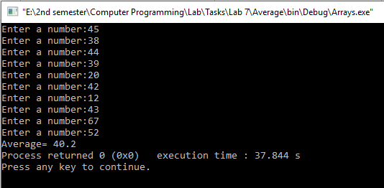

**TASK #3:**

Write a program to input multiple values from user using array and find the maximum (use separate loops for input operation and calculation).

**Code:**

#include <iostream>

using namespace std;

int main()

{

const int SIZE=4;

int A[SIZE];

for(int i=0;i<SIZE;i++) //Input Array

{

cout<<"Enter a Number: ";

cin>>A[i];

}

int Max=A[0];

for(int i=0;i<SIZE;i++) //Finding Max

{

if(A[i]>Max)

Max=A[i];

}

cout<<"Max= "<<Max; //Display Max

return 0;

}

**Output (Compilation, Testing and Debugging):**

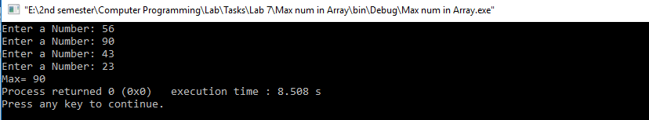

**TASK #4:**

Write a program to input multiple values from user using array and then ask user to input a key number and then compare it with values entered by user(for array) and then display the index number of array with which value get matched (use seperate loops for input operation and calculation) (use different loops for input operation and calculation).

**Code:**

#include <iostream>

using namespace std;

int main()

{

const int SIZE=4;

int A[SIZE],key,counter=0;

cout<<"Enter key: ";

cin>>key;

for(int i=0;i<SIZE;i++) //Input Array

{

cout<<"Enter a Number: ";

cin>>A[i];

}

int i=0;

while (i<SIZE) //Finding index number

{

if (key==A[i])

{

cout<<"Key found in index "<<i<<endl;

counter++;

}

i++;

}

if(counter==0)

cout<<"Key not present in Array";

return 0;

}

**Output (Compilation, Testing and Debugging):**

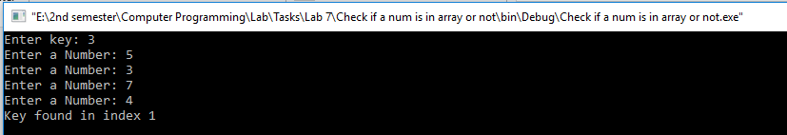

**TASK #5:**

Write a program to input two arrays from user and find the sum of arrays (element by element).

**Code:**

#include <iostream>

using namespace std;

int main()

{

const int SIZE=4;

int A1[SIZE],A2[SIZE],A3[SIZE];

cout<<"Enter Array "<<1<<":\n";

for(int i=0;i<SIZE;i++) //Input Array 1

{

cout<<"Enter a Number: ";

cin>>A1[i];

}

cout<<"Enter Array "<<2<<":\n";

for(int i=0;i<SIZE;i++) //Input Array 2

{

cout<<"Enter a Number: ";

cin>>A2[i];

}

for(int i=0;i<SIZE;i++) //Finding sum

{

A3[i]=A1[i]+A2[i];

}

cout<<"Sum of A1 and A2 = ";

for(int i=0;i<SIZE;i++) //Display sum

cout<<A3[i]<<" ";

return 0;

}

**Output (Compilation, Testing and Debugging):**

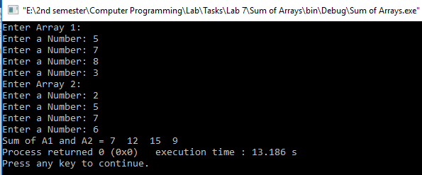

**TASK #6:**

Write a program to input array from user and display the elements of array in reverse order (use seperate loops for input and output operation).

**Code:**

#include <iostream>

using namespace std;

int main()

{

const int SIZE=4;

int A[SIZE];

cout<<"Enter an Array: \n";

for(int i=0;i<SIZE;i++) //Input Array

cin>>A[i];

cout<<"Reverse of this Array is: ";

for(int i=SIZE-1;i>=0;i--) //Display reversed Array

cout<<A[i];

return 0;

}

**Output (Compilation, Testing and Debugging):**

